**Outcomes**

The main outcome we want for our app is to supplement the mental health community, especially in Universities, to obtain better outcomes. We plan to do this in a few different ways. Our goal is to encourage more engagement in mental health programs, more informed mental health policy, feedback for the user for their own mental health, and methods of reducing mental health strain on the user. These outcomes will have the best possible impact on the mental health community.

**Engagement in Mental Health**

One area that we will improve is getting students/patients to interact more with the services provided. The current trend is that the rate of which students drop out because of mental health is on the rise. There could be several reasons why this is the case. One possible reason is that people do not know of or are reluctant to use mental help programs on campus. An app that attracts people to mental health services would help not only the user by getting them the help they need, but also help the university lower dropout rates. Having more people engaging in mental health services help the users as well as the universities.

**Informed Mental Health Policy**

Success in mental health programs can be a difficult metric to measure. From a university perspective, there needs to be evidence that the money is spent wisely because universities are a publicly funded institution. Data would show what programs were more effective over other programs year to year, and month to month. This can show trends that would otherwise not be noticed by mental health professionals. By collecting data about the aggregate mental health of the campus, universities can make better and more effective program decisions.

**Feedback for Users**

It is not just important for the universities to see the trend of stress within the lives of students, but the students themselves can get valuable information about themselves. Studies have found that journaling and tracking can be a excellent way of stress reduction. Students can then predict when they will be most stressed during a semester (e.g around due dates and midterms), and have a coping strategy in place ahead of time. This can also be helpful when combined with other tracking the student does such as nutrition or fitness. Feedback provides valuable information for the users as well as the universities.

**Mental Health Strain**

We want to look in an app that would not just serve those who need the programs offered by universities, but also those who are stressed without being overwhelmed. Throughout a semester, student stress levels can range from mild to severe. An app that addresses the mild stress and provide relief, can then be relied to help the same user when their stress levels become quite high, and needs professional help. This keeps users engaged with the app, and gives an easier transition to those whose stress levels increase to an overwhelming amount to engage in the mental health services. We want those who are not yet needed of mental health services to find the feature fun and calming. Fun and interactive features allows mental health services to intervene before users become too overwhelmed.

**MVP**

Our MVP is an app that will meet all the objectives laid out in the previous section. The app will engage the end user in mental health programs by giving the user information about available mental health programs at the university. The information will be accessible in the app, and highlighted when the user shows continual poor mental health over a period of time. This will be tracked through a mental health response feature recording moods day to day, ensuring that those who need the information the most have it. Users benefit by seeing the progress and trend of moods, and are able to get feedback on themselves and can adjust their lifestyle and routine accordingly. The information gathered on this feature will also be available to the University. Aggregated data gives the university the best overall scope of the campus mental health, ensuring that mental health programs are effective. The app will also have calming and distracting games. Users will initially engage with this aspect to help with their low levels of stress and anxiety. As the stress builds beyond what the games can realistically help manage, the app will recommend services to the user. By combining mood tracking, large data, engagement, and low level distraction, our app will complement current university programs, and improve mental health.

**Core Features**

Our application will have a login feature for security purposes and to aid in data collection. User information will still remain anonymous regardless of the login feature. The rest of the app is divided into 3 core functionalities: Mood tracking, games, and a mental health toolkit.

**Mood Tracking**

This will be the first screen that the user sees once they open the application. This aspect of the app will require users to self report their moods on a daily basis. There will be multiple moods to choose from to more accurately portray the user's’ mood. A calendar feature will also be integrated into this to allow users to view their moods in days prior and to assess when they are having consecutive bad days. The mood tracker acts to engage students by giving them a interface to interact with and give them feedback of their mental health. Recording the data generated by the students helps inform the university of the campus levels of stress, giving the university better information for mental health policies.

**The Games**

Once the users have reported their moods, they will be prompted to play a game. To begin, the app will offer one game but will expand to give the consumer base more diverse options to choose from. The game must be simple and easy to play. By having a game that distracts, low levels of stress is managed by the user. This also gives the user incentive to come back and use the non-game aspects of the app, like the mood tracking.

**Mental Health Toolkit**

Once the user chooses to stop playing the game, they will be redirected to a new screen which will provide information on all the mental health services available to them. Ultimately it is up to the user to utilize these services, however, this aspect of the app serves only to bring attention to the resources available. This helps spreads awareness of mental health services on behalf of the university, and the students.

**Optional Features**

Some of the initial optional features that would increase the value to the user include event/push notification and mental health. These notifications would again serve as tools to raise awareness to the services available to the user. As well push notifications would be linked with the calendar to notify the user that they have had a bad few days and to provide recommendations of services they may utilize. The mental health tips may be a separate screen to provide users with advice. For example, it may give the user tips on how to better deal with stress or even how to maintain proper study habits. A key optional feature would be a daily journal. This would allow the user to write down their thoughts each day. Our calendar feature allows the user to track how they were feeling each day, however, a journal feature would allow the user to track why they were feeling a certain way on a particular day. The journal would be viewable to only the user.

Additional features to the game aspect would be adding more complex games for those who like to be challenged. Even integrating a points/reward system to entice the user to open the app every day. Including a chat room or forum where users can chat with each other anonymously is also a possibility. It will be up to the user’s discretion whether or not they would like to continue to remain anonymous. This helps users find people going through similar circumstances, and helps users find someone to relate to. General options include expanding the languages the app is available in as the consumer base grows. The final optional feature would be a routine tracker. This would monitor fitness (with potential fitbit connectivity), alcohol consumption and drug use and these all have an effect on a person's mood. This would help explain variations in stress levels for the user, increasing feedback.

**Workflow**

The app approaches the issue based on short and long term solutions for the user. The focus of the app is to monitor behavior and respond accordingly. Workflow revolves around a user’s daily experience, requiring user engagement and feedback. Users will record their experience based on a quantifiable metric (scale, good/bad, etc.). As more data entries are recorded, certain trends may emerge, and will trigger an action in the app. If the user records three negative entries sequentially, the app will send a notification to the University mental health service. The user will then be presented with options regarding the available mental health services from the university. They can then choose to engage in the services, and address any mental health issues they are currently experiencing. The data recorded in the mood tracker is available to the user in the toolkit section of the app, and is presented in the form of charts and graphs. This same data is also sent to the university for further analysis, and the information is used with existing mental health programs. When users are experiencing temporary stress, they can engage in the game section of the app. If the user’s stress is not relieved with the game experience, and the user requires further assistance, they will then proceed to the service recommendations.

**Storyboard**

In this section, we will be looking at three different user interfaces designed by our team to gather data on the final possible user interface for the app.

**User Interface 1**

The first user interface (Appendix A) was designed to give an emphasis on tracking the user's moods throughout the week. The app has notifications giving encouraging the user to check into the app regularly (1). Checking in (2), the interface displays the past few entries, as well as some customizable options for images. There are several descriptive functions in the journal entry creation, such as a range of emotions to choose from, and general comments. Once the user has made their entry, they can see their progress with the app (4), with the journal entry, mood, date, and graphical representation of their moods. If the user has a few bad days in a row, they are shown to the information to mental health services (5). This is always available in the main menu (6) along with tools, activity checklist, and check-in feature. Because this design was in pencil, we cannot see how the design would look with colour.

The main advantage of this user interface is that the moods and tracking feature of the app are central to the design, and much of the rest of the app is designed around that. The range of emotions to choose from give better accuracy for self-reporting. The emphasis on displaying the immediate past few days helps users choose how they are feeling, giving a reference point to their emotions. This along with the simplicity of the display makes each screen as easy to use and understand as the last. The notification feature that brings you directly to the check-in function is an excellent way to ensure people are checking in everyday. A disadvantage of the design is how many menus there are, and how hard it can be to track where you are in the app. Although there is a home button, navigation would be the most difficult aspect. Having too much information at once overwhelms the user, and it is not immediately clear what they are expected to do at each screen. Additionally, although the data is important, moving the emphasis towards more of the fun and interactive part of the app would attract those with mild stress or anxiety, so more people would use the app.

**User Interface 2**

User Interface 2 (Appendix B) greets you immediately with your name, and four options (1).With few pages, all the navigation would be at the bottom of the device. The check-in feature (2) simplifies the check-in with a simple “good-day” or “bad-day”, with the history of previous days displayed. When there are enough concurrent “bad-days”, the user is brought to the information of university services (3), also available from the main page. Finally, the user has the pick from three different games (4). The two features not shown are the settings as well as profile and stats.

This user interface focuses on simplicity, and making it easy to use. Each feature of the app is accessible at anytime from any other feature of the app. Apps that are simple to use and understand have more people coming back to use them. The downsides of this design is that it is simple to the point where some of the feature are not informative. For example, the check-in feature have two options, does not account for the wide range human emotions have. Even though this design is not cluttered, it has the problem of not having enough in the app, making the features look empty and not well thought out.

**User Interface 3**

The third User Interface (Appendix C) has four separate features. The mood tracking is rated out of 5 in a chart, with the most recent entries on display (1). This simplifies the option, without giving too much in terms options away. Each entry is rate, and the progress is shown graphically (2). Each section is navigable from any other feature in the app. The games feature (3) shows one of many games available for the app. Finally, services information is located on the app when there are days where the user is feeling down.

Like user interface 2, user interface 3 focuses on simplicity. Being able to navigate to any other feature reduces complexity, and users are more likely to use the app more often. The simplicity is not lost on the tracking feature, because having a rating out of 5 is quantifiable to both users and those administering the app. One drawback to this design is that people are better able to relate to faces rather than numbers for feelings. Secondly, not having a calendar where users can see their progress makes it difficult to visualise their progress, and that a graph needs a calendar in this situation. The app also lacks colour, making it feel cold. If we are trying to get users to open up to the app and share their feelings, we want the app to be warm and inviting.

**Evaluation**

The three UIs were evaluated based on usefulness, engagement, pros, cons and general feedback from the individuals who evaluated the UIs. We chose to gather feedback from University students aged 18-24, who would be the most likely to use this app. We had nine students who responded, three of which are women. Most students were between second and third year. Every student we gathered feedback from reported feeling overwhelmed with stress within the last year. These are exactly the demographic we hope to target with our app. The raw data can be seen in Appendix F, and in the response section. The students received emails with a link to our survey, and each othe user interface storyboards. They were asked to give numerical ratings for usefulness and engagement, comments of what they liked and disliked about each design, and general comments. This method combined qualitative and quantitative data to create the best feedback as possible.

**Numerical Feedback**

Usefulness and engagement were evaluated on a 5 point scale. In each criteria, 1 represented the least useful/engaging, and 5 represented the most useful/engaging. By measuring usefulness and engagement, we can isolate if the user interface has more of an aesthetic flaw, rather than a overall design flaw. The most useful user interface is UI 1, and UI 3 only slightly less useful. The most engaging user interface is UI 3, with UI 1 and 2 rated similarly. These results are helpful, however none of the UIs stand out as having overwhelmingly positive feedback in either category. When looking at engagement, the results are especially inconclusive as the results were spread across all of the ratings and none stood out as definitively positive or negative. This means that the ratings cannot be used exclusively to determine the final design of the user interface.

**“What aspects of the UI did you like?”**

Respondents in the survey found UI 1 to be informative and detailed, and noted that there is a link to resources for mental health. They also liked the fact UI 2 shows clarity and a strong and simple layout. There were two individuals who indicated that nothing stood out as positive about this UI. The positive feedback for UI 3 indemnifies that this iteration uses a scale for mood rather than just good or bad, the game is also highlighted by two evaluators. UI 3 and UI 2 both struggled to get positive feedback from the respondents, indicating that they may not be the strongest interfaces on which we base our final design on.

**“What aspects of the UI did you not like?”**

Looking at the question of ‘what aspects of the UI did you not like’ there are four individuals who feel that UI 1 is cluttered. The other stand out comment is that the UI 1 appears to be quite boring, possibly because it was not done in colour. UI 2’s feedback suggests that it may not be very professional and may in fact be a bit childish in its appearance, there are also multiple individuals who feel that this UI does not provide information. The feedback for UI 3 suggests that the layout for this UI may be a bit dated and not very interesting. Some individuals also feel that UI 3 may be a bit lacking in providing a positive and welcoming feeling. The responses in this section show that, although UI 1 is more informative, there needs to be an emphasis on simplicity to engage users.

**General Comments**

The comments and general feedback for the UIs will help us fully understand the previous results and decide which UI we should pursue for further development. The feedback for UI 1 has a theme of having a lot of information, some do find this to be a bit too much while others actually like this. The feedback also identifies that UI 1 is not very visual and may benefit from visual elements, specifically for mood tracking. We will base the app functions after UI 1. The responses for UI 2 has a recurring theme of lacking functionality, while being a more personable and friendlier design. The usage of space for this UI may not be optimal in the current state as identified by multiple individuals. One individual also identified that there was only one game, and that they would like to see more. This could be an opportunity for future development. Overall the feedback for UI 2 suggests that while this design may be more visually appealing, it is lacking in functionality, and the individuals who provided feedback favor function over form. The feedback for UI 3 is quite mixed, some individuals feel that this may the best UI of the 3, while others feel that it is very lacking. Specifically, some individuals feel that the UI is lacking in visual appeal and functionality. Some individuals have identified that they like the game aspect of this UI which is both a risk and opportunity. While the game may bring users in, we would have to balance this with the prevalence of the game to the other aspects of the app. One individual identified that a combination of UI 1 and UI 3 would give the app the proper balance between usefulness, and engagement.

**Final UI decision**

Our final design (Appendix F) incorporates all the aspects in our app that we have either done well, or have received feedback for and have improved. The design has all the aspects of UI 1 that people surveyed responded to positively, with the simplicity and engagement aspect of UI 2 and UI 3.

After logging in, the user is immediately brought to the check in screen, and is giving a range of options to categorize how they are feeling. Those who were surveyed responded to both the sliding bar, and the emoji to represent their emotions. The surveyed also responded well to having a persistent menu, so most aspects of the app is one touch away from any other feature. We have also decided to leave a comment section to help users track what sort of events stressed them out, or to be more specific with their feelings.

If the user has already checked in for the day, then the default menu on opening the app is the day mood tracker page. It is similar to the check in page, in that it shows the emoji corresponding to the entry for that day, as well as any comments. This improves feedback by allowing users to compare their emotions to their most recent entries, making future entries more accurate. This aspect is connected to the calendar feature, where previous entries are available for quick reference. The graph feature has been improved to be more friendly, and display the most recent values of mood to the user, as well as the dates when the user entered the moods. The time frame that the graph represents can be changed to show overall trends in the user’s behaviour.

Once the user has made entries, then the app monitors for unhealthy mental health. If there are a certain amount of poor health ratings in a row for the user, then they are shown a screen asking if they need further assistance from the university. Rather than automatically sending them to the information page, the user must take some responsibility for their decision to get mental help. If the user agrees, they are taken to the information page. The page is always available to be accessed in the app with the persistent menu. This feature however, encourages the user to seek help. Along with the campus information, the app supplies people with various common mental health problems. Users in the survey said that they liked information to be available to them, but in an organized fashion. Each article has it’s own page, in a simple and easy to read format. Although this app will not diagnose the user, they will have a better understanding of symptoms that would not be considered normal, and would therefore be more inclined to seek help.

Having six or more games keeps users engaged in the app. Those surveyed had mixed reviews about the game choice in UI 3. By having multiple games, we ensure that we reach as many students as possible because the app will have something everyone would enjoy. The games, along with the subtle use of colours, ensure this app is as pleasing to the eyes as it is useful.

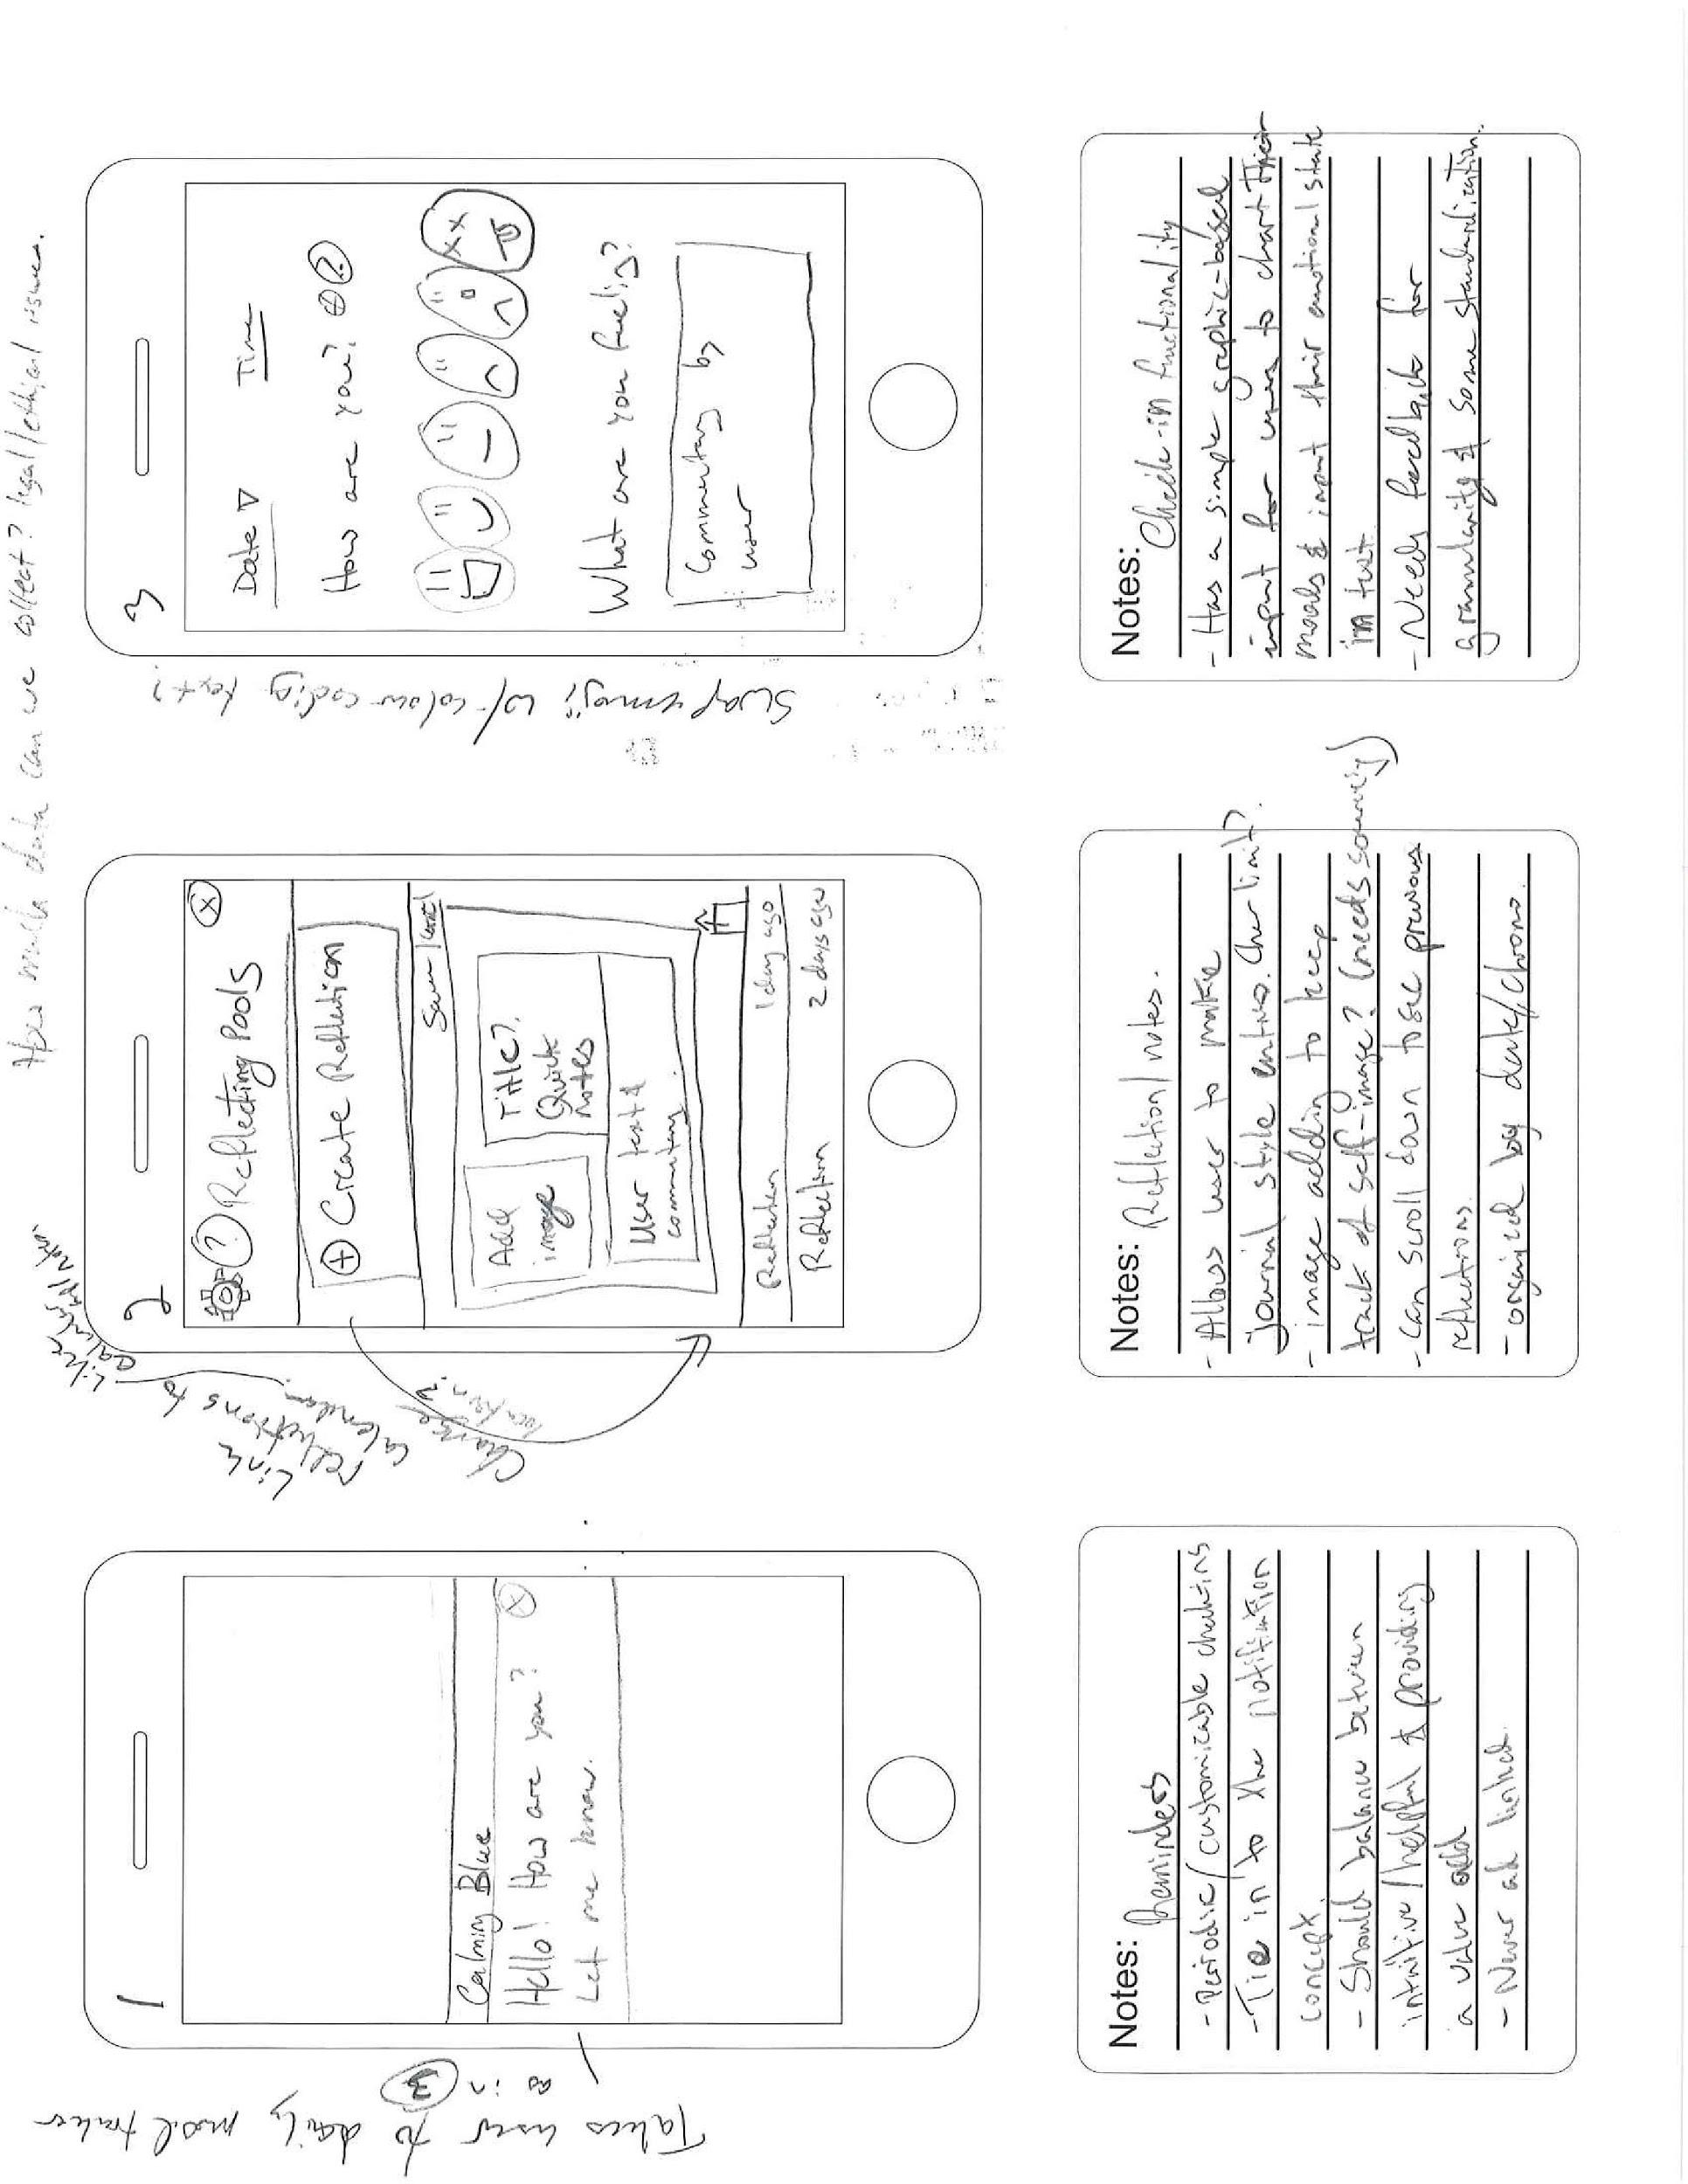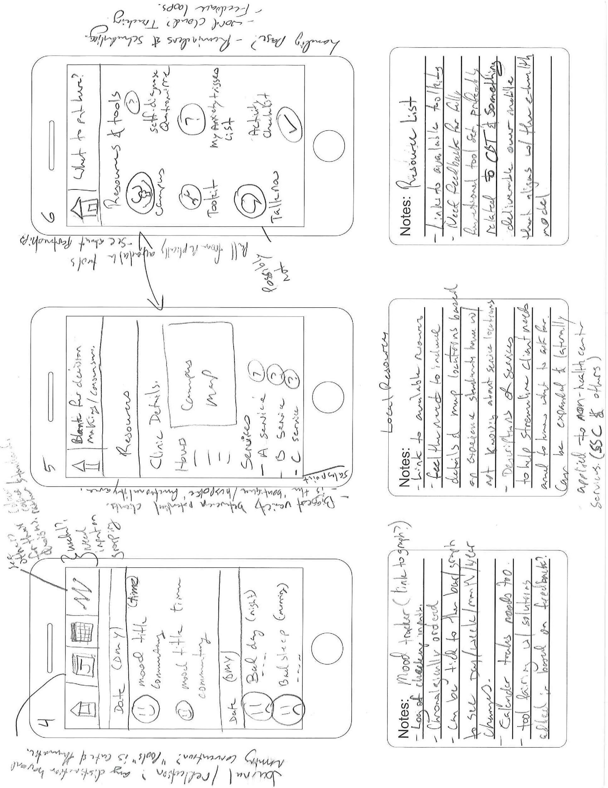

Appendix A-UI 1

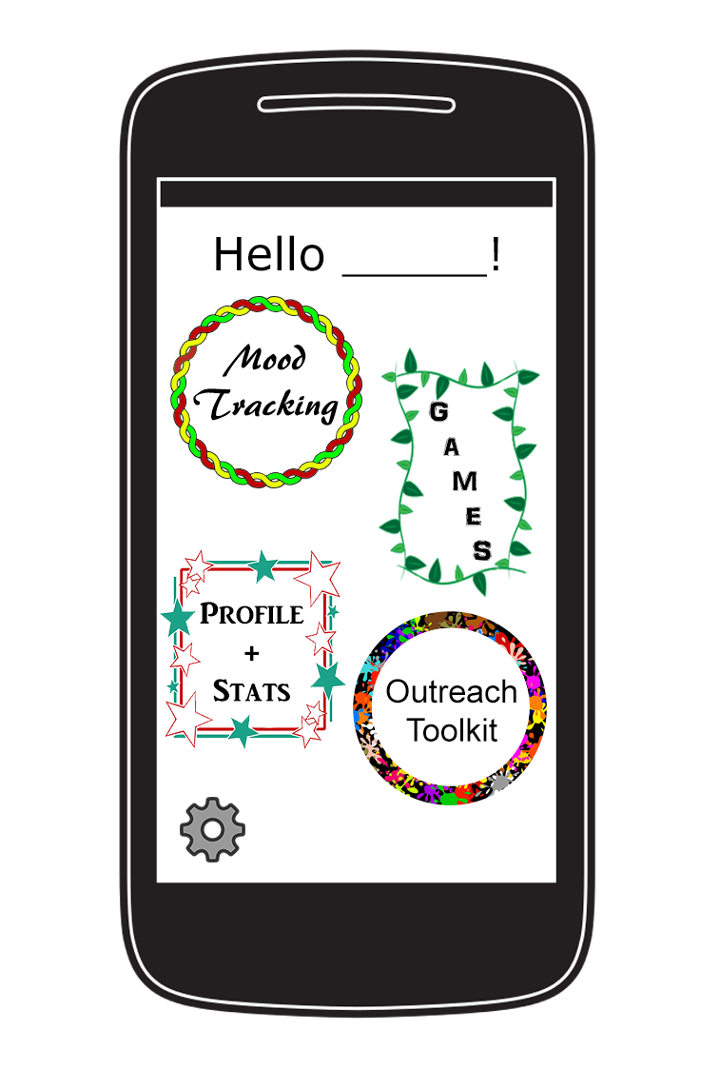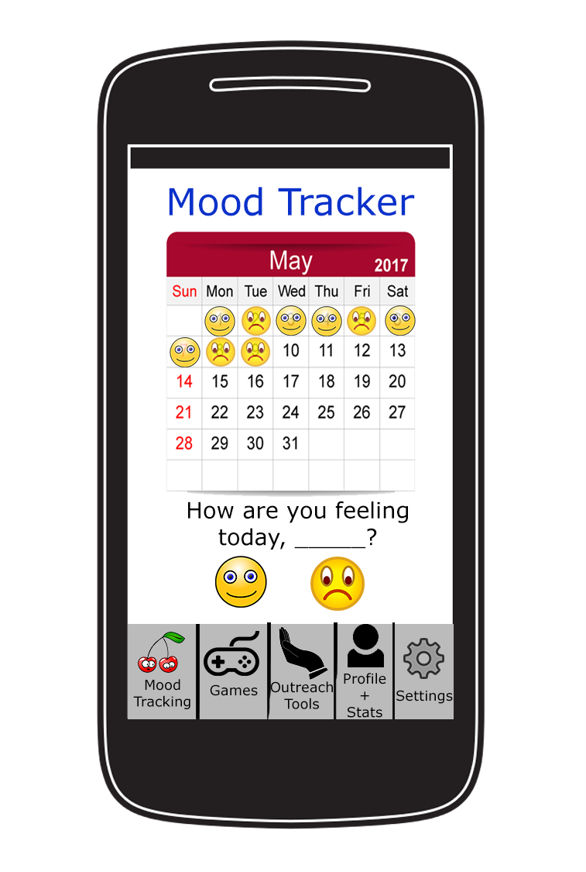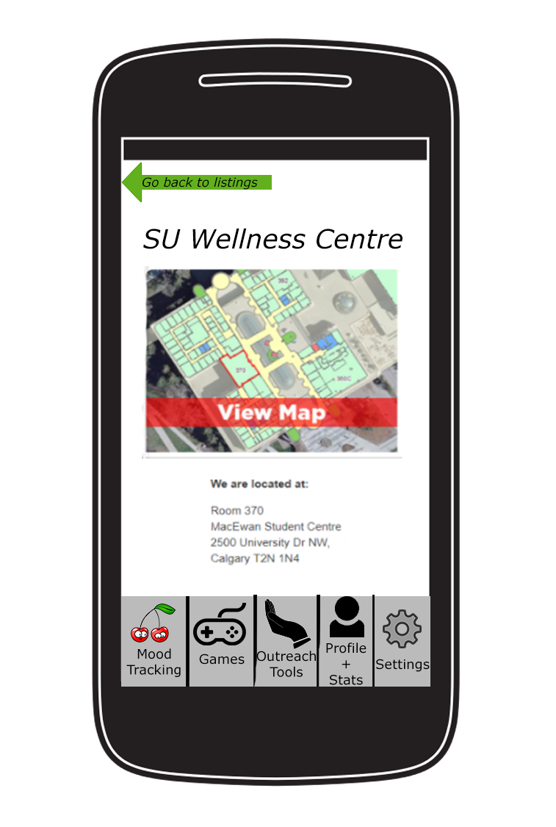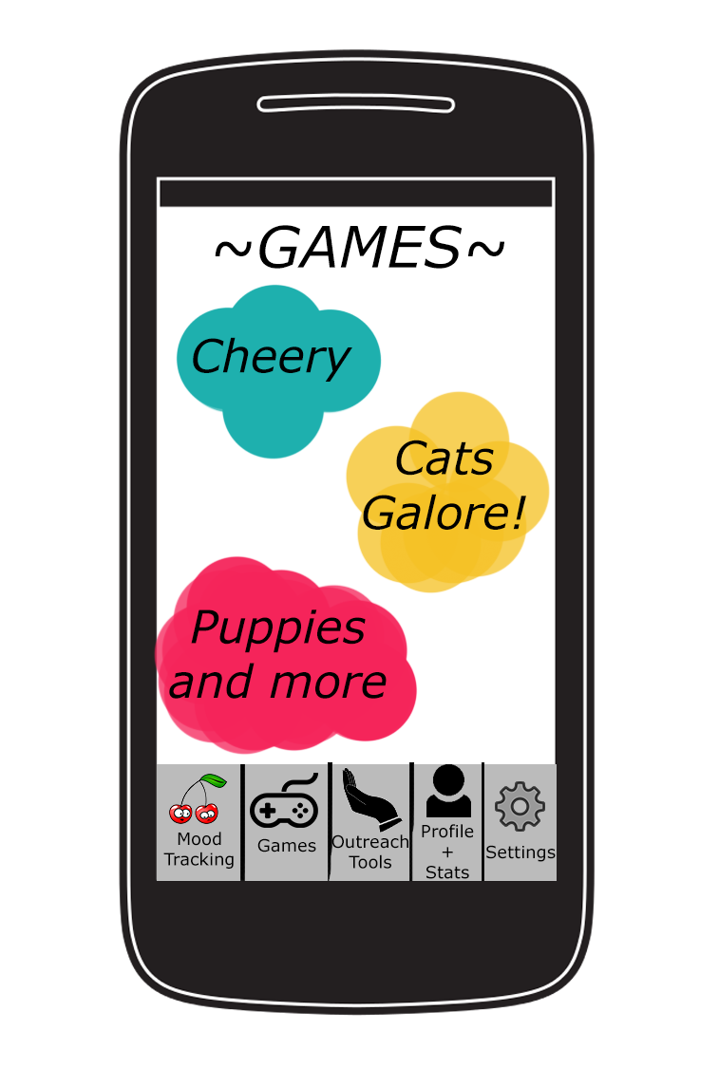

Appendix B; (1), (2), (3), (4)- UI 2

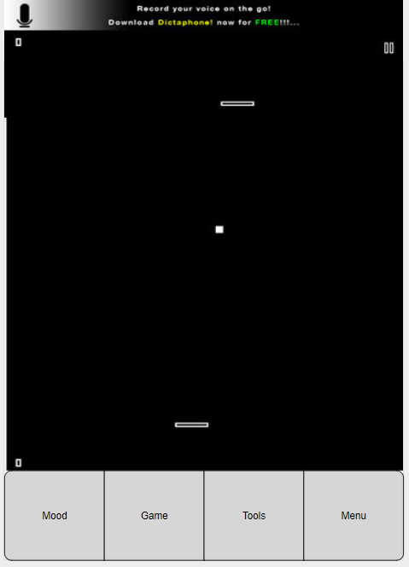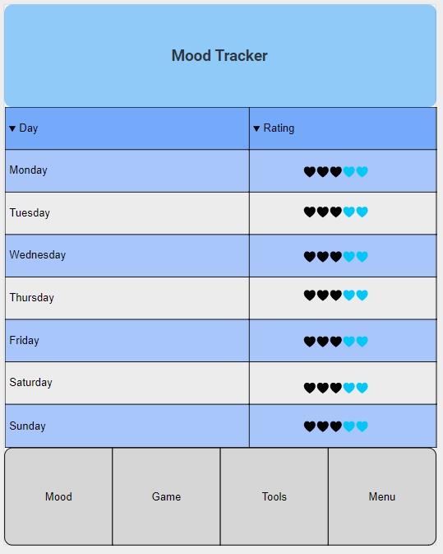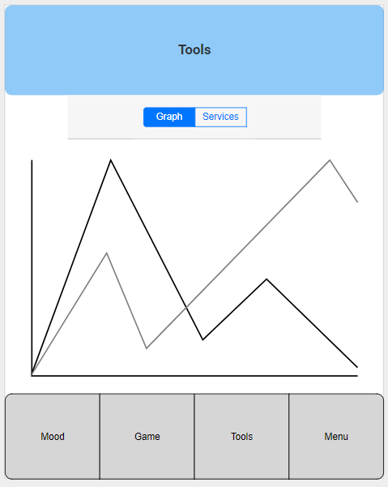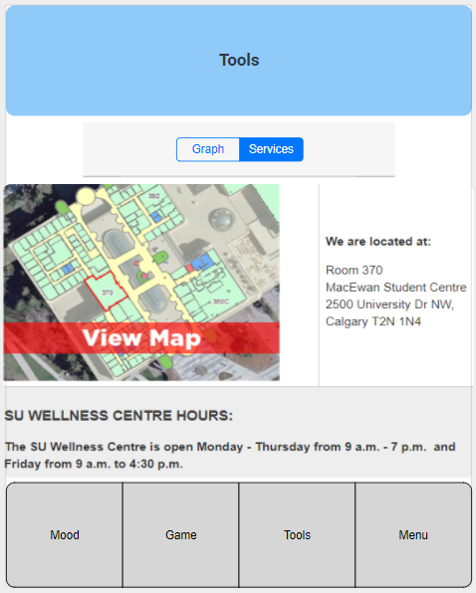

Appendix C (1), (2), (3), (4)- UI 3

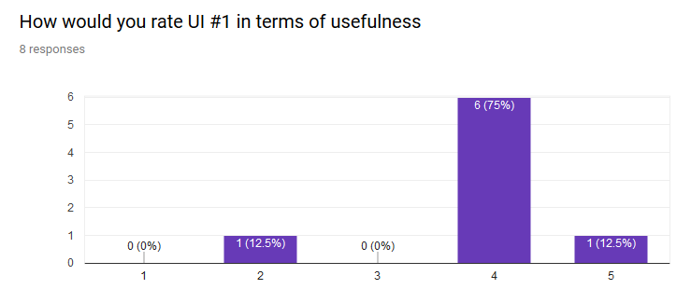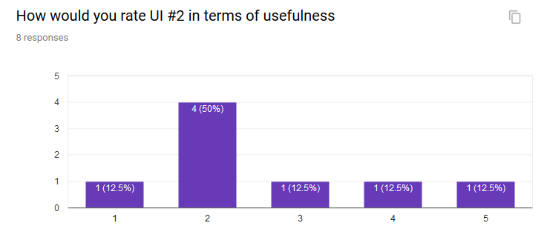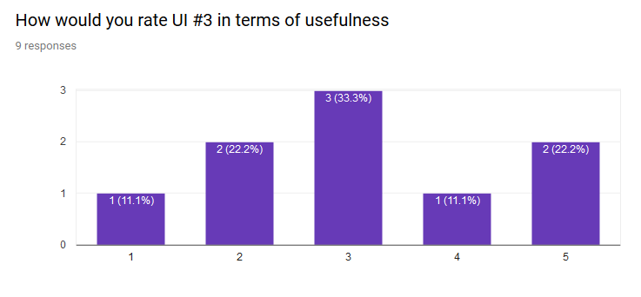

Appendix D

Appendix E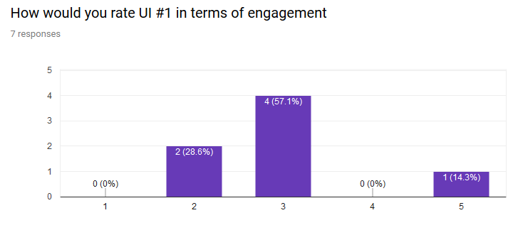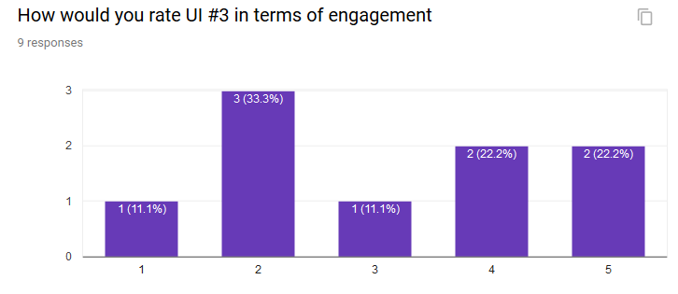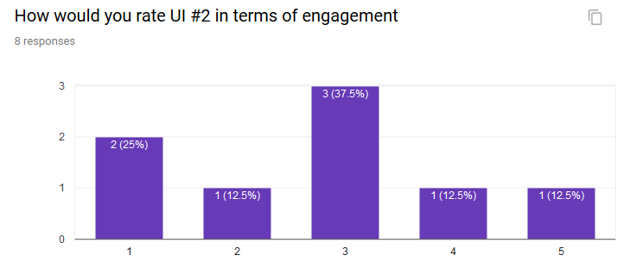

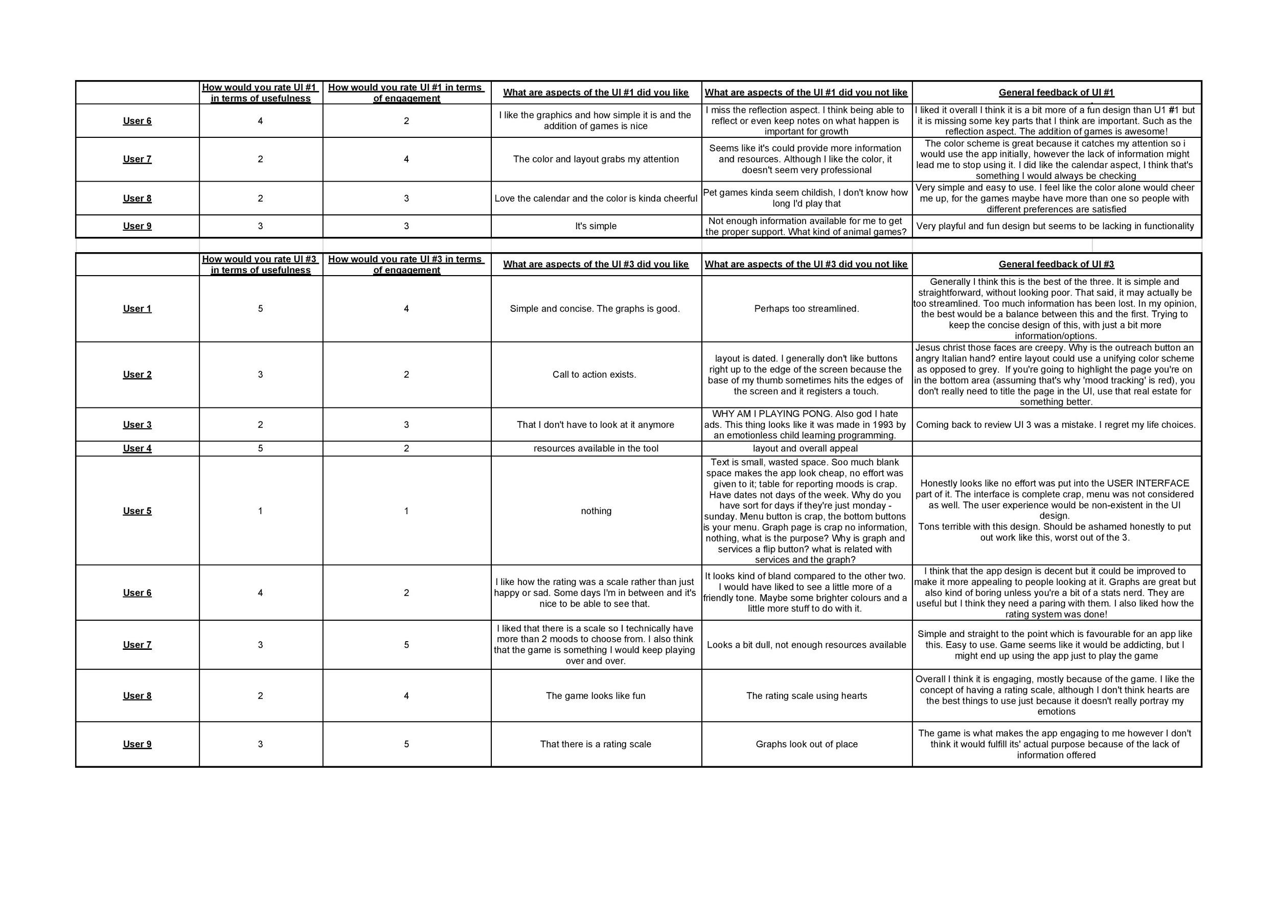

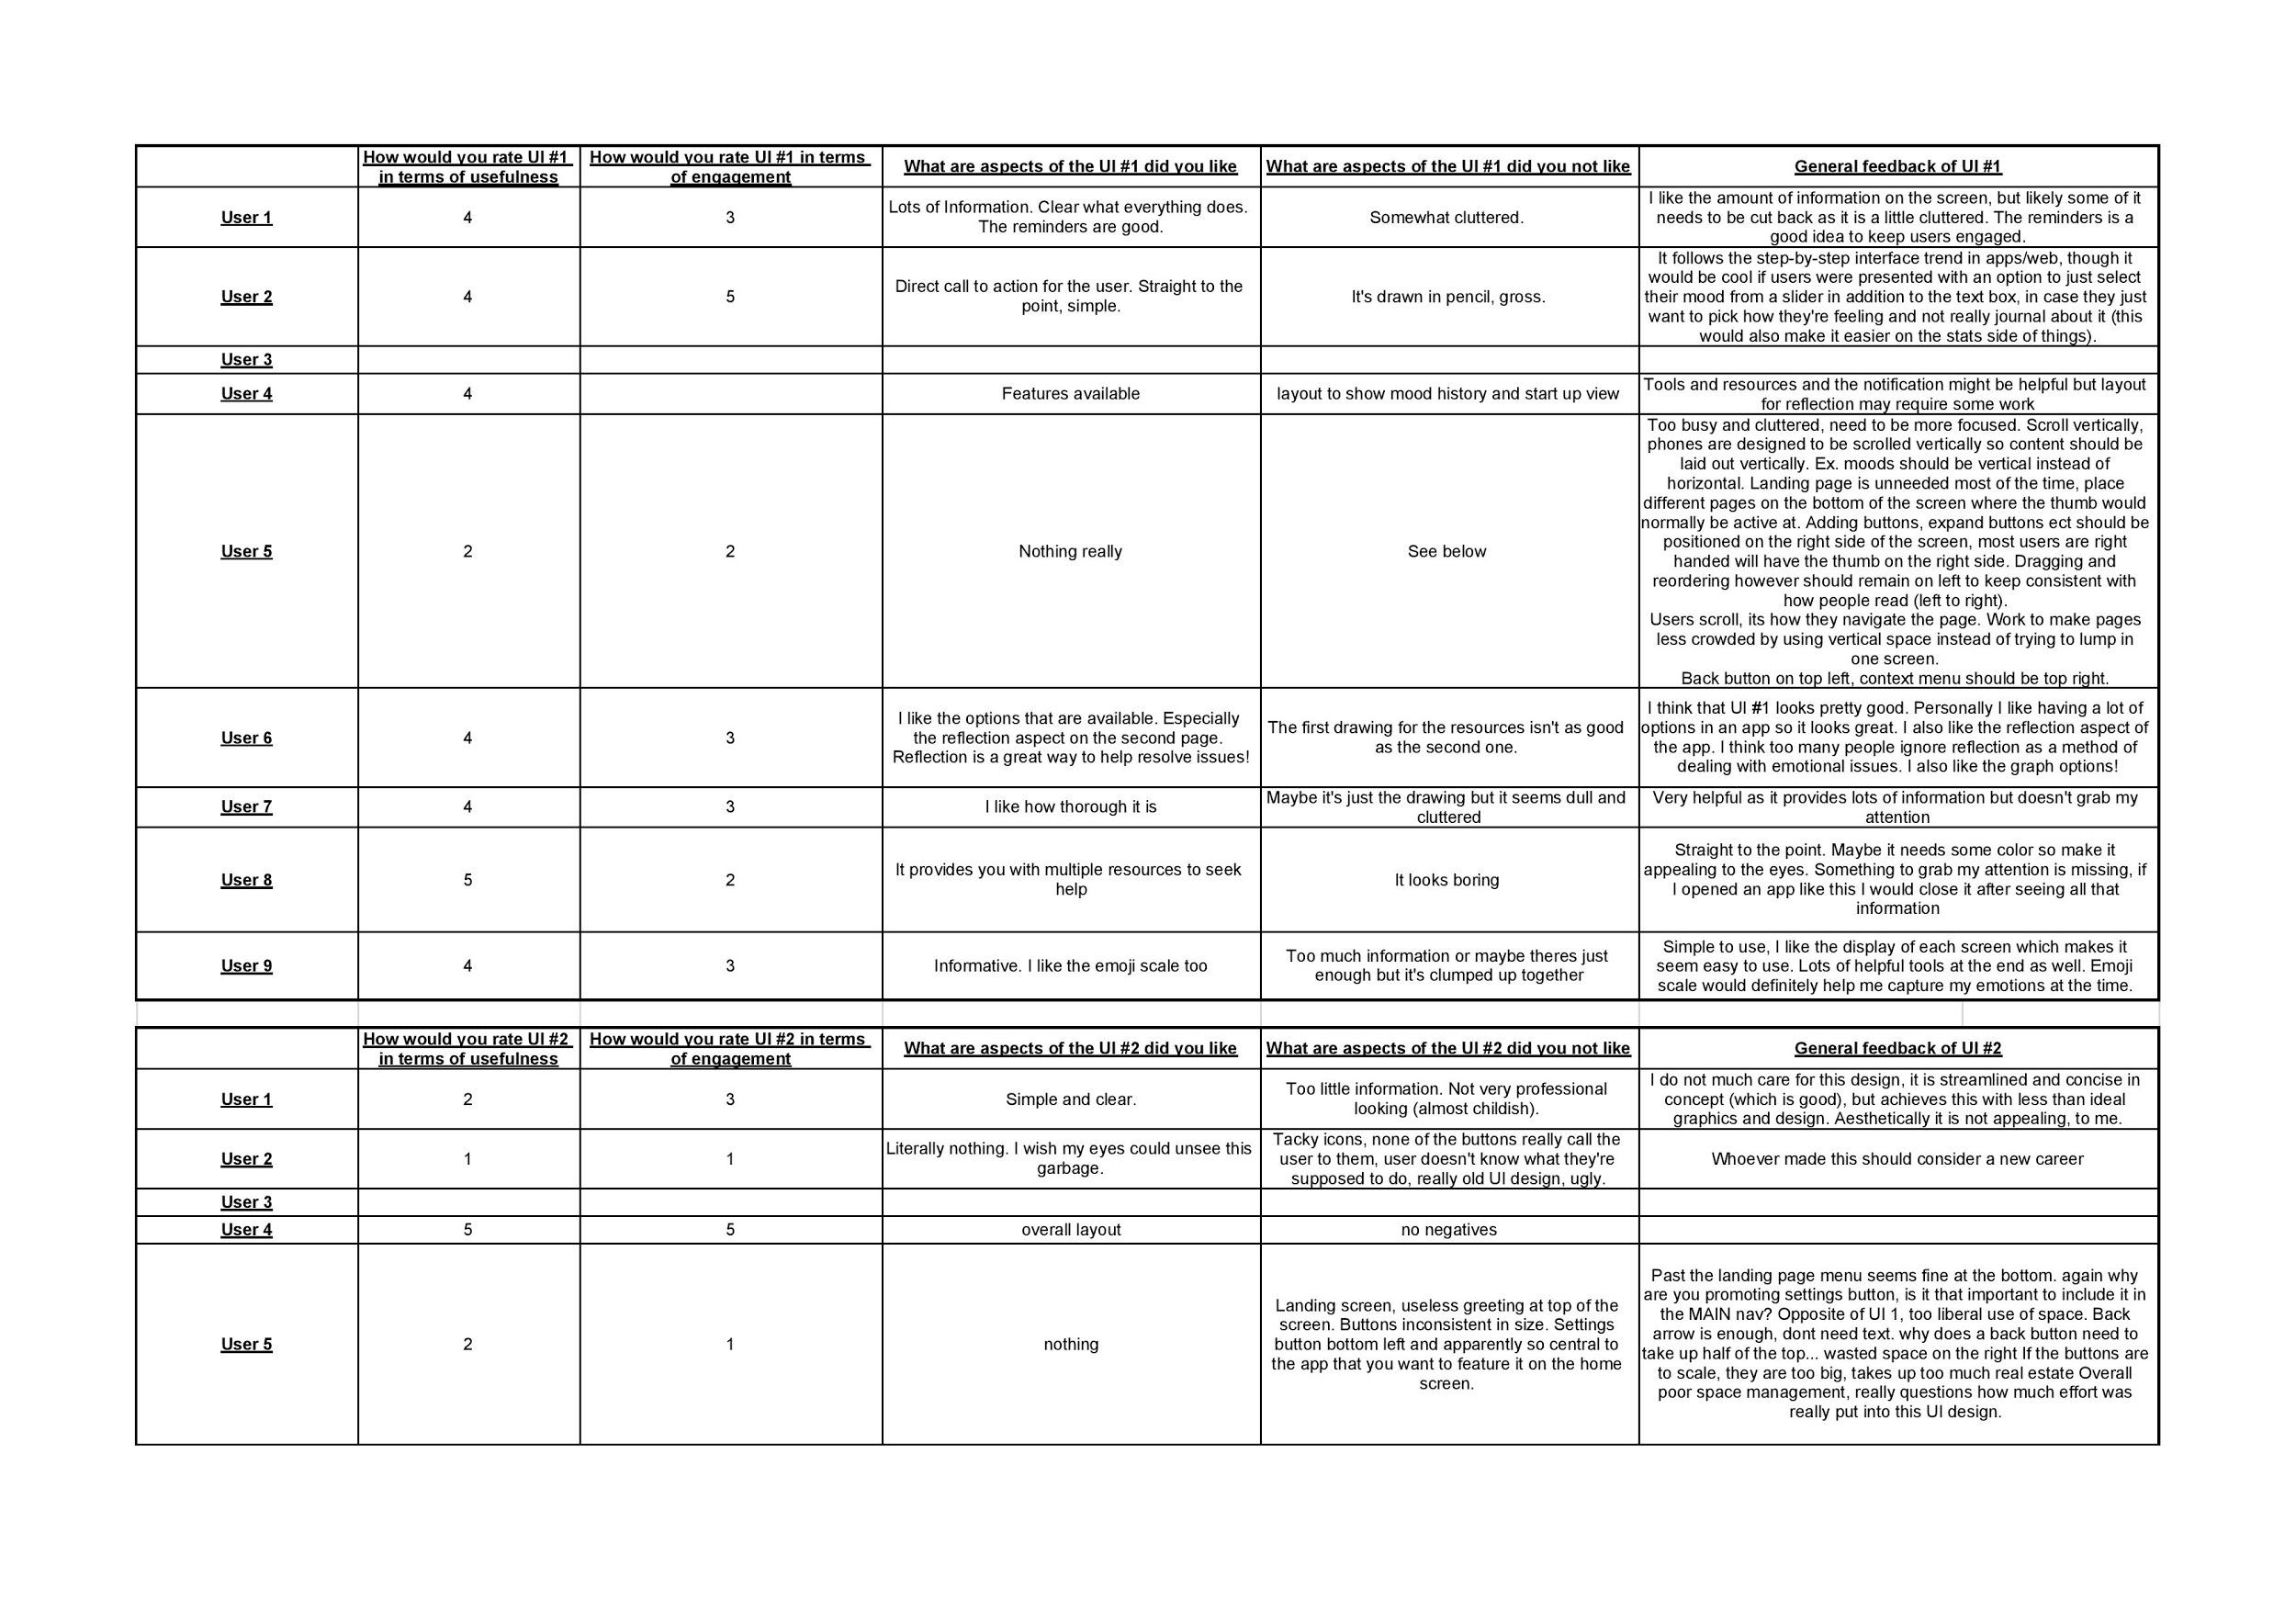

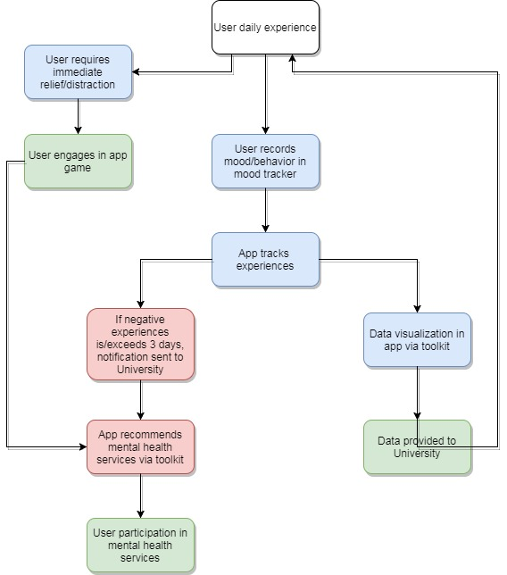

Workflow Diagram

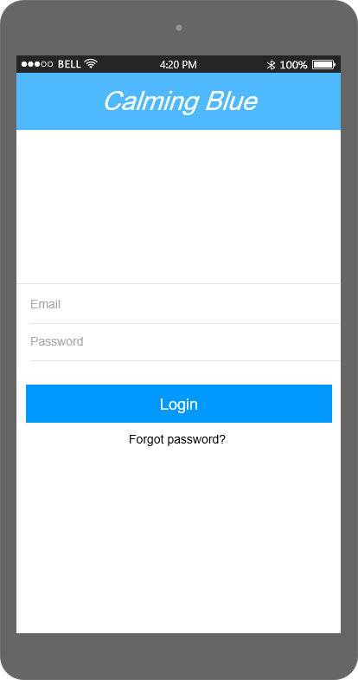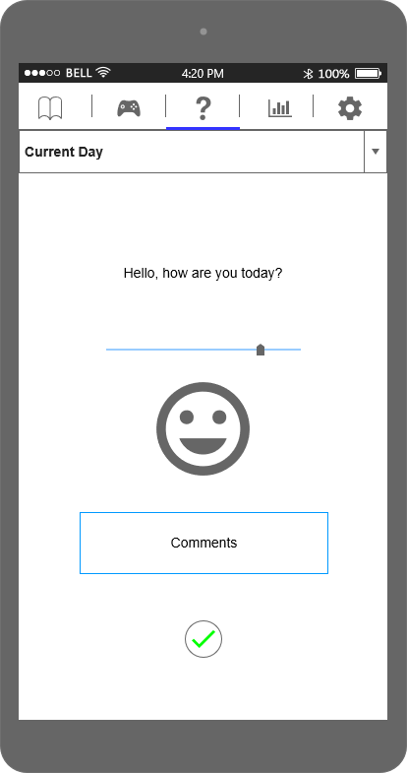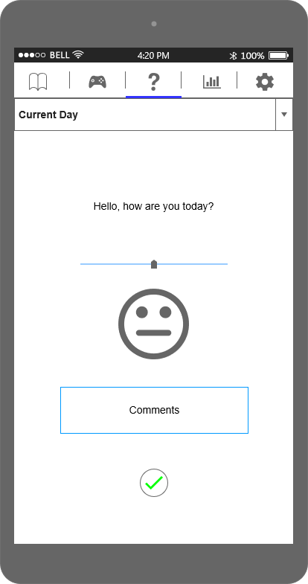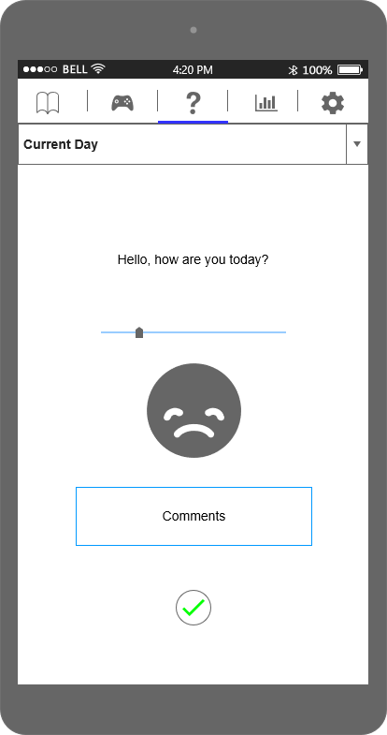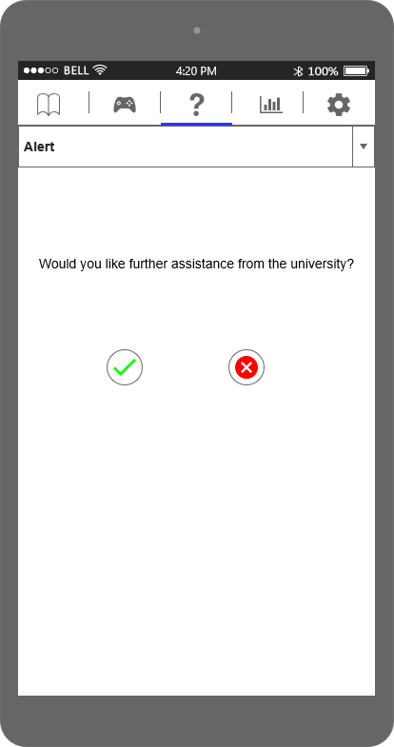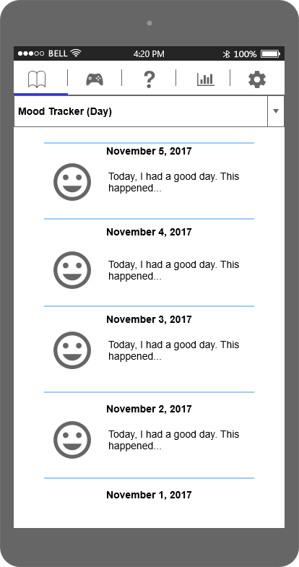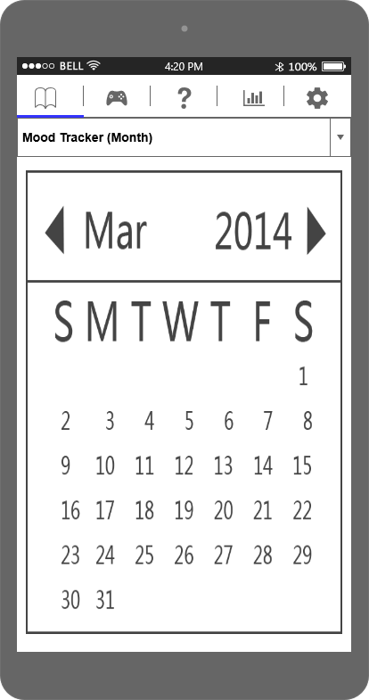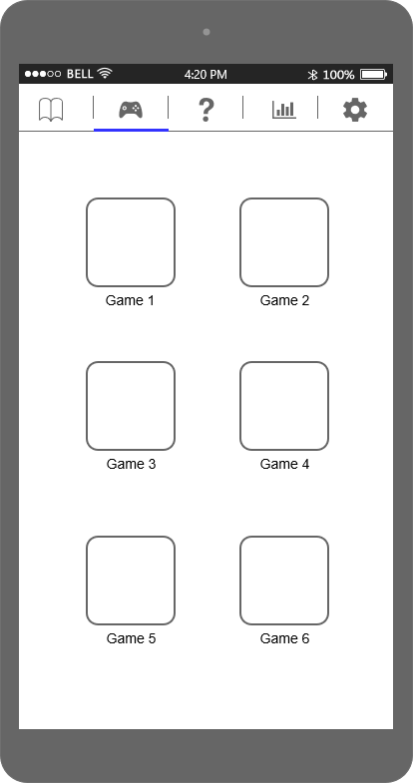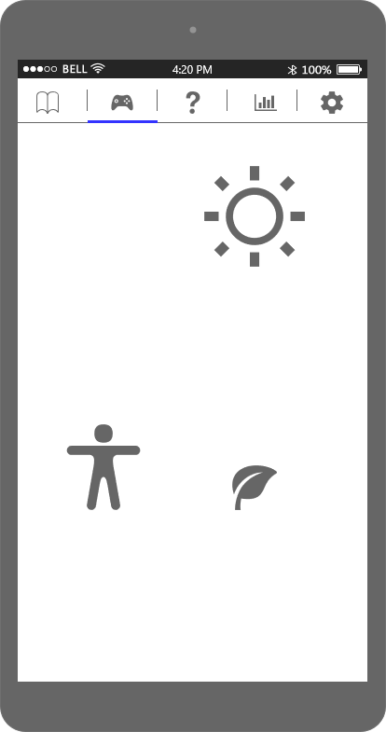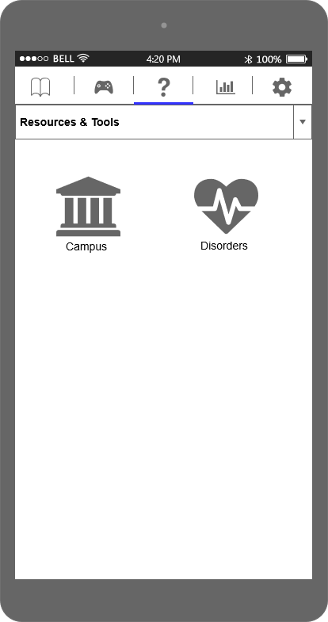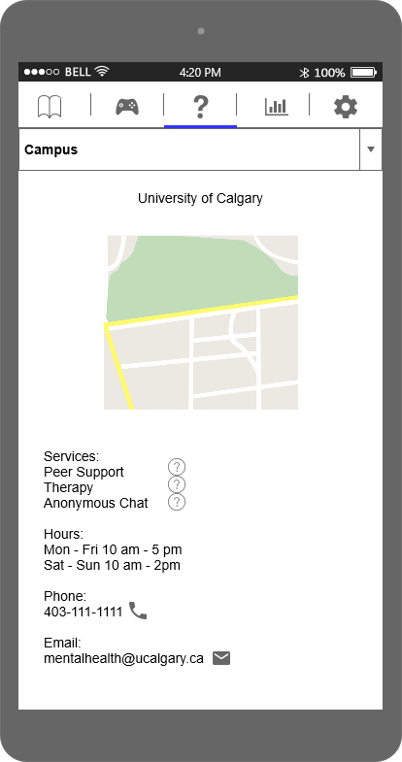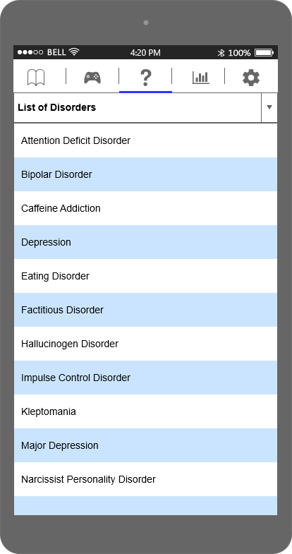

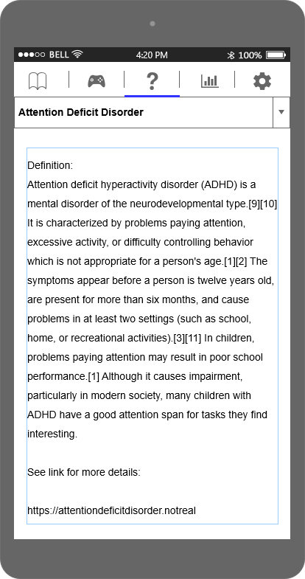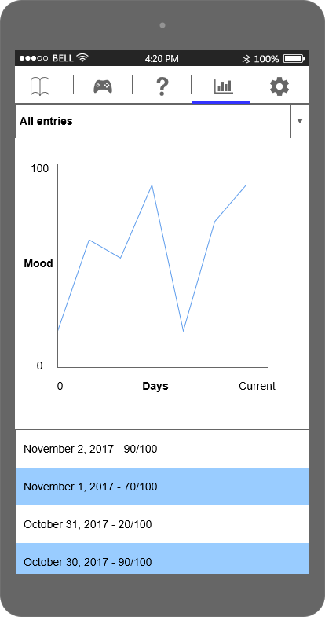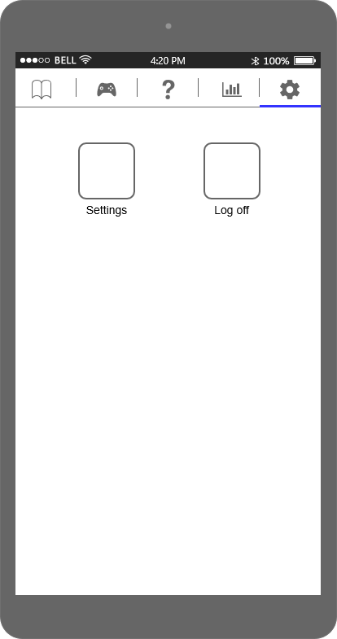

Appendix F (Final UI design)